MORAVIAN AND INVERNESS ORIENTEERING CLUBS
NORTH DISTRICT OPEN ‘COLOUR CODED’ EVENT – CULBIN FOREST WEST
Sunday 13th June 2010
INCORPORATING THE MORAY & HIGHLAND JUNIOR ORIENTEERING CHAMPIONSHIPS

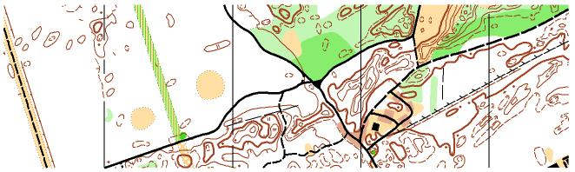
To many orienteers, within Scotland and beyond, Culbin is the Hampden Park or Wembley Stadium of the sport. Orienteers travel the length of the country to practice their sport on this ‘hallowed turf’. Thanks to the support of the Forestry Commission, we are thrilled to be able to stage Moray’s first ever junior orienteering championship in such a wonderful venue for this exciting adventure sport. We hope that this event will provide an inspirational taste of competitive orienteering for many youngsters here in the North who have recently discovered the sport through school. If you are a regular orienteer, you will know what to expect. Gloriously fast terrain on forested sand dunes with areas of wonderfully complex contour shapes to test your navigation skills to the full, with a very good network of paths and trails to provide easier courses for beginners. The will be a full range of colour-coded courses from Brown to White, and once planning is complete, full details of these will be published here.
This early information is mainly aimed young people and their parents from Moray and the Highlands who are thinking about entering the event. Please read through the notes below and don’t hesitate to get in touch with us if you have any questions.
Venue. Parking for the event will be at Wellhill Car Park near the village of Kintessack by Forres at grid reference NH996614. There are on-site toilets.
Eligibility. The Junior Championships are open to boys and girls under the age of 17 on the day of the race living in the Highland or Moray regions. There is also a full range of courses of various lengths and technical difficulty for anyone else to enter.
Entries and Registration. Because we have to print maps in advance for every competition, we would like all competitors to enter the event on line via the link on our web page. There will be limited entry on the day, subject to spare maps remaining. Entries will open on 23 April and will close on Monday 7th June. We will order a small number of spare maps but we cannot guarantee that last-minute entry for any course will be available.
Entry Fees. Entry fees will not be confirmed until we know the overhead expenses. However, we anticipate that it will be £3.00 per junior competitor. Adult runners in the colour-coded classes can expect to pay £7 with a £2 discount for adult members of British Orienteering.
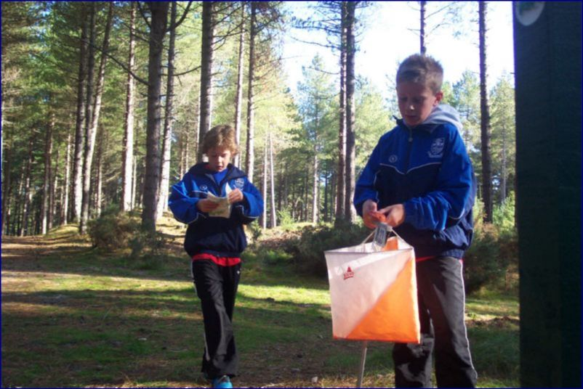
The Competition. Orienteering is a cross country race. But instead of following a set course you have to navigate your own choice of route via a number of checkpoints (or ‘controls’) marked on a special map. Start times are spread over a long period with only one runner starting on any course at each minute interval. Because there are 8 different courses set out in the same area, you will see other runners who are running to different controls. Timing is done by an electronic tag called an EMIT ‘brikke’. You activate it at the start and use it to clock in at each control and at the finish before it is read by a computer which checks the course has been done correctly and works out your time. The skill in orienteering is to match your running speed to the speed you can read the map and not get lost! There is lots of information available on the internet, particularly the British Orienteering website www.britishorienteering.org.uk. All orienteering events in the UK are open to all, and you can find the nearest events to you on the “Event Information” section of this site.
Entry Classes. In the Junior Championships, there are boys and girls races for 4 age groups as shown in the table on the next page. The competition is aimed at novices, but we are also holding a separate open junior elite race for experienced junior orienteers who have more advanced orienteering skills. Age classes are based on the competitor’s age ON THE DAY OF THE RACE. There are 8 courses available for anyone to enter outside of the junior competition, and these are also shown on the next page.
JUNIOR COMPETITION ENTRY CATEGORIES
Category | Course | Technical Difficulty | Approx Distance
Boys Under 11 | 1 | Very Easy | 2 Km
Girls Under 11 | 1 | Very Easy | 2 Km
Boys Under 13 | 2 | Easy | 2.5 Km
Girls Under 13 | 2 | Easy | 2.5 Km
Boys Under 15 | 3 | Moderate | 3 Km
Girls Under 15 | 3 | Moderate | 3 Km
Boys Under 17 | 4 | Moderate | 4 Km
Girls Under 17 | 4 | Moderate | 4 Km
Boys Open Elite | 5 | Hard | 4 Km
Girls Open Elite | 5 | Hard | 4 Km

Competitors are welcome to run in an older age category. Anyone wanting to enter an easier or shorter course can still take part but should enter the appropriate ‘colour coded’ class as shown in the following table. Such competitors will be ineligible for the championship.
COLOUR CODED COURSES OPEN TO ANYONE
Course Name | Technical Difficulty | Approx Distance
Brown | Very Hard | 11 Km
Blue | Very Hard | 7 Km
Green | Very Hard | 5 Km
Light Green | Hard | 3.5 Km
Long Orange | Moderate | 4 Km
Orange | Moderate | 3 Km
Yellow | Easy | 2.5 km
White | Very Easy | 2 Km

Shadowing. Orienteering is an individual sport and in regular championship events, anyone wishing to remain competitive must not be accompanied out on the course. However, the aim of the Junior Championships event is to introduce novice youngsters to an exciting running sport in a safe environment, and while it is a competition, we want everyone to enjoy their day. Parents are therefore welcome to shadow their children on the course if they wish. However, to be fair to those children who run unaccompanied, we rely on parents to let your children do the navigation themselves. Only provide assistance when it is obvious that your child has made a mistake. We don’t want to see parents running round with map in hand with a child in tow – we want children to enjoy the challenge, excitement and satisfaction of doing it all themselves. Likewise, children may run with a friend, but EACH MEMBER of the pair must register separately and will be treated as a separate competitor.
Timings. Registration, with limited on-the-day entries, will open at 10.30 am. Start times will be from 11.00 to 13.00 with courses closing at 15.00. Depending on the number of entries, competitors might be allocated a 15-minute start block in order to avoid congestion at the start. Course maps and timing brikkes will be issued at registration for all courses except the junior elite. Competitors will therefore be able to plan their routes before they start.
Prizes. There will be trophies awarded to the winners of all 10 categories in the Moray & Highland Junior Championships. We plan to hold the prize giving as soon as possible after 13.30. There will be no prizes for the colour coded courses.
Further Information. This information sheet will be updated with further information as and when it becomes available. For more details please contact the event organisers as follows:
Moray area:
Mike Rodgers on 01309 6141413 or by e-mail to alisonrodgers@supanet.com

Highland area;
Sue Nicolson by e-mail at INICOLSON@aol.com

